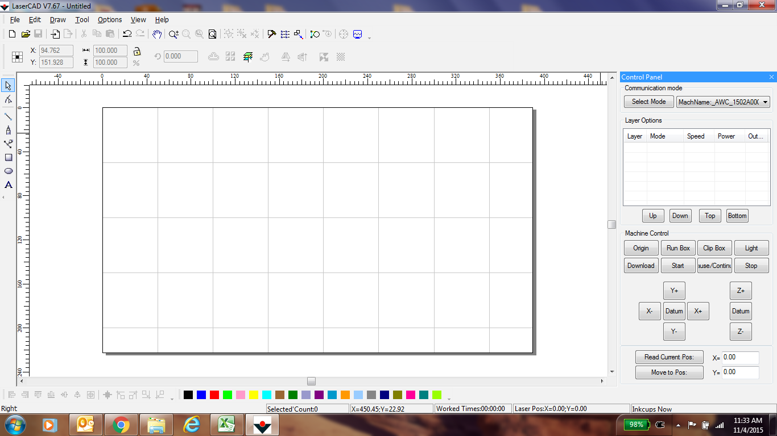

Dead space – Do not position artwork

X AXIS

Y AXIS

Page corner

50mm

50mm

50mm

**When positioning the artwork, add 7mm to the X-axis coordinate in order to compensate for the table rail. Add 50mm to the Y-axis to compensate for dead space.**